**ITA0448 – STATISTICS WITH R PROGRAMMING FOR VECTORIZED EXPRESSIONS**

**SUBMITTED BY: DEVADARSHINI J REG NO: 192124092**

**DATE: 21/03/2023**

**1. The built-in vector LETTERS contains the uppercase letters of the alphabet. Produce a vector of**

**(i) The first 12 letters;**

**(ii) The odd ‘numbered’ letters;**

**(iii) The (English) consonants.**

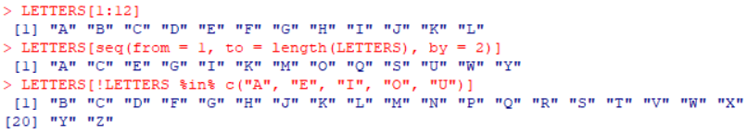

**2. The function rnorm() generates normal random variables. For instance, rnorm(10) gives a vector**

**of 10 i.i.d. standard normals. Generate 20 standard normals, and store them as x. Then obtain**

**subvectors of**

1. **the entries in x which are less than 1;**
2. **the entries between – 0.5 and 1;**
3. **the entries whose absolute value is larger than 1.5.**

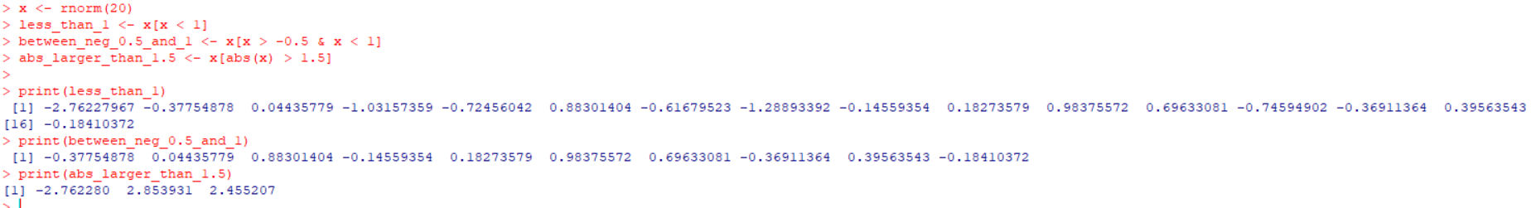

**3. Solve the following system of simultaneous equations using matrix methods.**

**a + 2b + 3c + 4d + 5e = −5**

**2a + 3b + 4c + 5d + e = 2**

**3a + 4b + 5c + d + 2e = 5**

**4a + 5b + c + 2d + 3e = 10**

**5a + b + 2c + 3d + 4e = 11**

**4. Create a factor object for an apple color such as “green”, ”green”, ”yellow”, ”red”, ”red”, ”red”, ” green”. Print the factor and applying the nlevels function to know the number of distinct values**

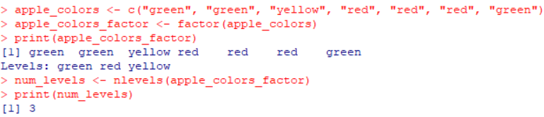

**5. Create an S3 object of class fruit contains a list with following required components such as name, quantity, cost and also define and create s4 objects. Define a reference class of fruit**

